Selective Chapters of ‘Simulation-based comparison of precision and accuracy of optimal linear estimation (OLE) and Bayesian phase models (OxCal) in estimating origination dates’

The original work from which these chapters were taken was from my dissertation submitted in partial fulfilment of the requirements for my MPhil in Archaeological Science at the University of Cambridge. It was inspired by the question, “Have the breakthroughs in statistical models necessarily resulted in high-precision chronologies”?

Accordingly, the study aimed to compare radio-carbon calibration techniques, a Bayesian phase model and a frequentist modelling technique to investigate how accurately and precisely they perform under the same sample size and diffusion rate parameters.

The methods were improvised to account for similar parameters and uncertainties as much as possible, taking up four distinct approaches: OxCal with a trapezoid phase model, OxCal with a uniform phase model, OLE with a modified median extraction method and a custom OLE resampling method. All Chapters, with the exception of those on Introduction, Results and Discussion, and Current Limitations and Further Prospects, have been attested in this document.

Total no. of pages – 20 (excluding figures, bibliography, and appendix)

Background

Archaeology permits observing temporal variation in behaviour and cultural processes (F. Plog, 1973).

Radiocarbon dating in archaeology:

Archaeological research associates the researched narratives with time – chronology (J. P. Hart, 2015). With the introduction of Radiocarbon dating, chronological construction became revolutionised. The technique allowed comparing dates and events across more considerable distances, liberating from placing regional archaeological assemblages in relative chronological order (R. E. Taylor and O. Bar-Yosef, 2014). Furthermore, radio-carbon recording devices evolved from beta-counting instruments to state-of-the-art AMS (accelerometer mass spectrometry), providing quicker results on much smaller samples (R. Hellborg and G. Skog, 2008).

Radiocarbon Calibration:

Due to fluctuation in the global radiocarbon concentration over time, calibration utilising a calibration curve is an imminent procedure in C14 dating. The isotope used in dating is the relatively radioactive and unstable Carbon-14, one of the element carbon’s isotopes. Results of C14 dating are reported in radiocarbon ages and are converted to calendar dates through calibration. The radiocarbon measurement assumes that the atmospheric concentration of C14 has remained constant since 1950 and 5568 years as the half-life of carbon-14.

The calibration is primarily needed to account for the atmospheric concentration changes on carbon-14 over the periods, which factors like nuclear testing, fossil fuel burning, etc., have caused over time. One of the most reliable and common calibration methods is usually done by dendrochronology (Beta Analytics, 2016).

Accordingly, calibration curves are constructed primarily through tree ring sequencing, wiggle matching, etc. The calibration curve is usually represented by calendar/dendro timescale on the x-axis and radiocarbon ages on the y-axis. Since the calibration curve goes under constant revisions as the understanding of the earth system improves, the most recent, InctCal20, has been utilised for this study, which extended back to 55,000 cal BP (Reimer et al., 2020).

Further, calibrating radiocarbon ages to calendar dates and summarising them derives insights into the time-frequency variations of radio-carbon dates, which is used to infer the underlying population density or its changing cultural trends (E. R. Crema, 2022).

From Figure 1, We assume the event under consideration occurred at calendar date θ, measured in years BP. The radiocarbon date depends on the calendar date; we represent it by µ (θ). Y is an estimate of µ (θ) and has many possible values since each actual measurement will produce a different result because of statistical variability. Therefore, Y is a realisation of a random variable.

Y = µ (θ) + noise

The noise represents the laboratory measurement error resulting in inaccuracies. The noise, or error term, is conventionally assumed to have a normal (Gaussian) distribution, with a mean of zero and a variance represented by σ2.

Y **~** N (µ (θ),σ2)

(Buck et al., 1992)

In Figure 1, the y-axis marks the radiocarbon concentration in BP (before present), and the x-axis is calendar dates derived from tree ring data. Y is the red bell curve on the Y axis, which is the radiocarbon age/concentration in the sample. The normal distribution encompassing the C14 age [µ (θ)] is determined by the ± error rate given by the instrument’s measurement recording error margin.

The band of blue curves denotes the radiocarbon measurement derived from tree rings, ± 1 standard deviation. The calibration works by the red normal distribution projecting itself to the calibration curve and reflecting it. The reflected result, subjected to peaks and troughs, is denoted in calendar dates. The distribution’s 95% most likely interval is later taken (OxCal, 2023).

OxCal:

The OxCal program generates radio-carbon calibration and analysis of archaeological and environmental chronological information (OxCal, 2023). The Bayesian phase model works based on the fundamental Bayes theorem in chronology, combining prior information and analysed results to produce the posterior distribution.

*p*(**t | y**)  *p*(**y | t**)*p*(**t**)  
**t** - set of parameters (a parameter is a date assigned into an object, e.g. a=200, start=Age(N(4896,10)))  
**y** - observations or measurements made.   
*p*(**t**) - *prior* or the information about the parameters (mostly events) we have apart from the measurements.   
*p*(**y** | **t**) - *likelihood* for the measurements given a set of parameters.  
*p*(**t** | **y**) - *posterior* probability or the probability of a particular parameter set given the measurements and the prior.

In Bayes’ theorem applied in chronological analysis, calendar date information is expressed as the *likelihood* (the same achieved image as seen in Figure 1) and the relative date information as the *prior* (Bronk Ramsey, 2009).

Prior

The standard calibration equation for generating likelihood already has prior information regarding the calibration curve embedded in it.

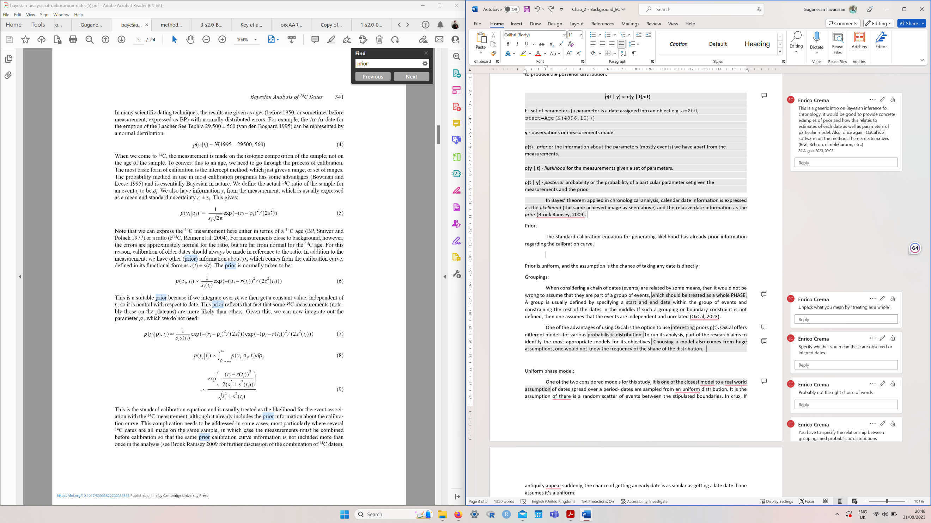

For a single event, this would be all needed. If only a single event is analysed, then the prior to the event’s date is considered to be uniform,

p(ti) ~ U(– ∞,∞ ) ~ constant

So, the Bayes’ posterior probability density is the same as the likelihood. So, for a single C14 age,

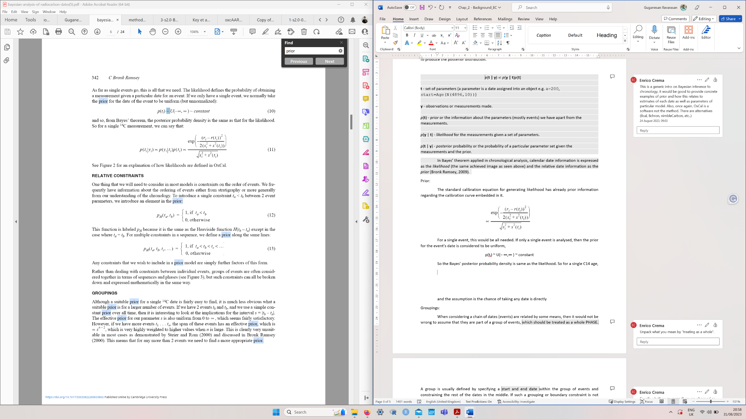

(Bronk Ramsey, 2009).

Relative Constraints

If the chronological or stratigraphical order of the dates is known, then they could be constrained, which could be added to the prior. e.g. ta < tb, then an element is added to the prior

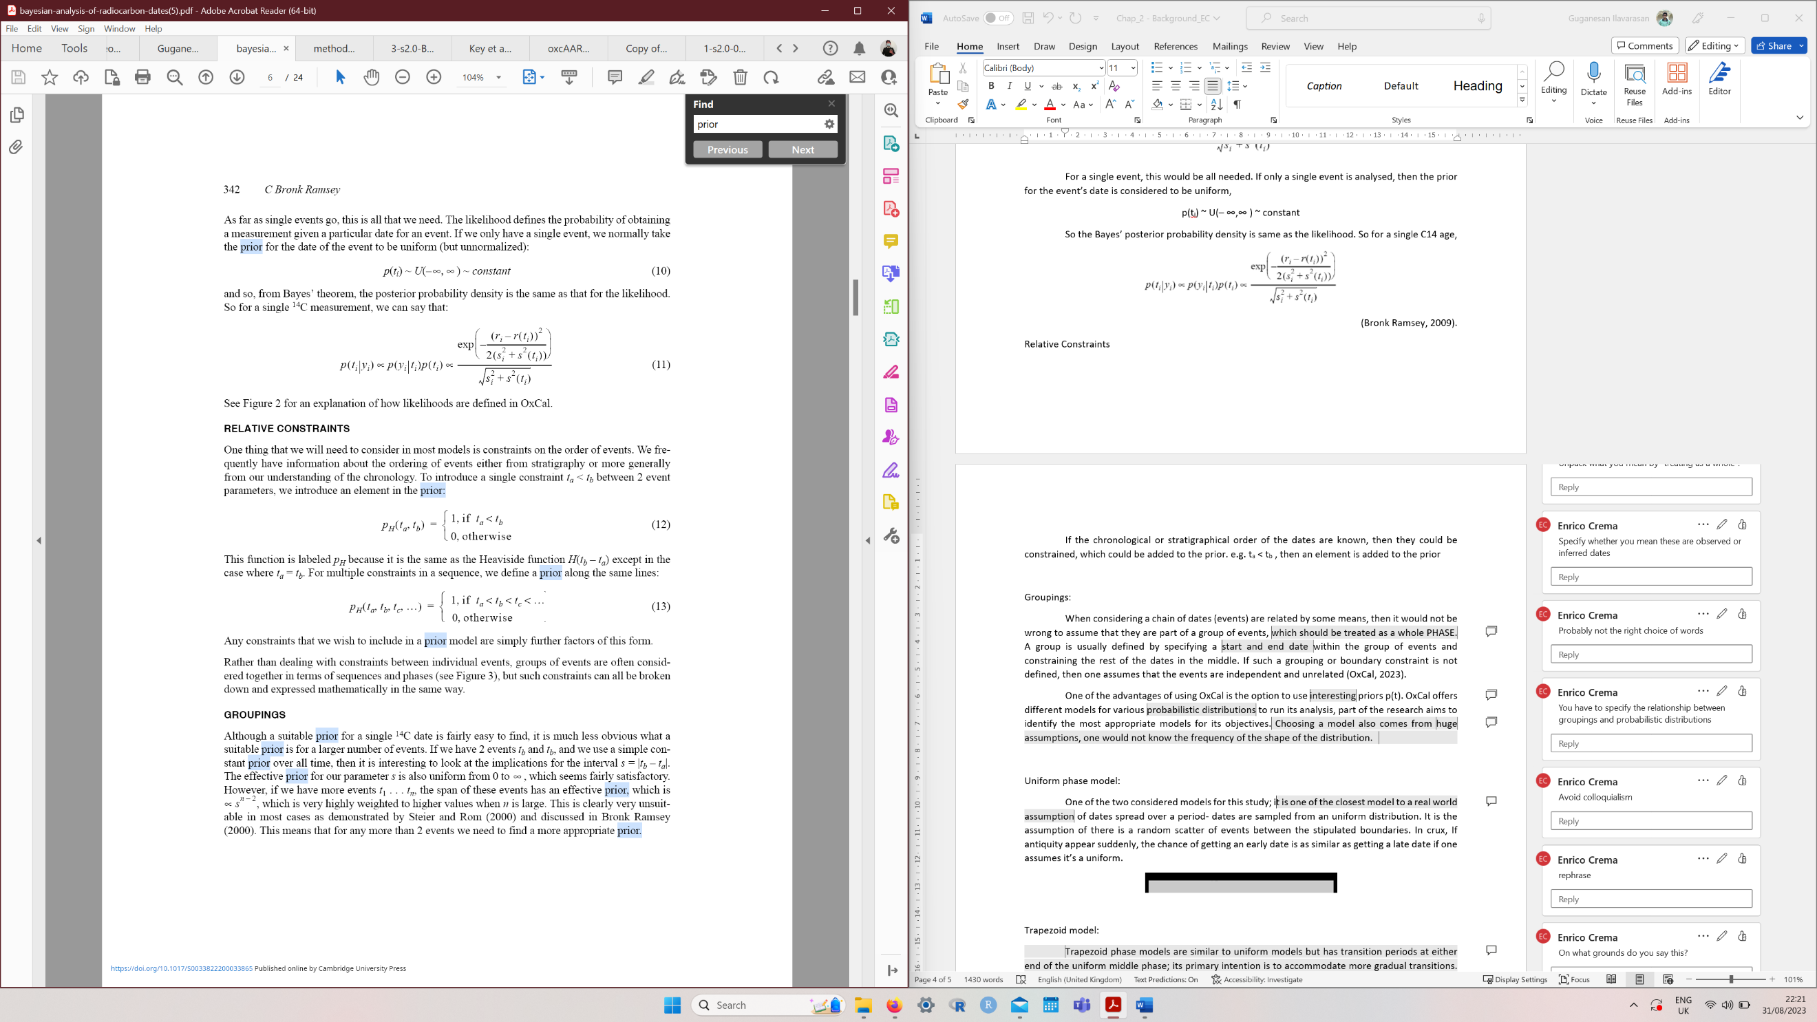

Where Ph is similar to the Heaviside function H(tb – ta).

Furthermore, instead of having constraints between individual events (solo dates), groups of events could be constrained in sequence and phases (Bronk Ramsey, 2009).

Groupings:

When considering a chain of dates (events) are related by some means, it would not be wrong to assume that they are part of a group of events, which should be treated as a (homogenous) phase. A group is usually defined by specifying observed (chronologically relative) start and end dates within the group of events and constraining/ordering the rest of the dates in the middle. If such a grouping or boundary constraint is not defined, then one assumes that the events are independent and unrelated (OxCal, 2023).

One of the advantages of using OxCal is the option to use different priors p(t). OxCal offers various models for different probabilistic distributions to run its analysis; part of the research aims to identify the most appropriate models for its objectives.

With the default model being uniform, other shaped models could be defined with two controlling boundary events in the same way as the uniform phase. For example, if the events within the phase are expected to grow, a ramped prior could be used (Figure 2).

A tau boundary could be used at the start for a model with events ending at an exponential growth rate but with an unknown start period (time constant), presumably lost during a layer's destruction (Figure 3).

Similarly, underlying processes with two parameters- definite start and end events, could be dealt with in models with different functional forms. As one would not know the frequency of the shape of the distribution within the events (dates) that will be analysed, choosing a model always comes from significant assumptions (Bronk Ramsey, 2009).

For example, in this study, we choose trapezoid and uniform since the simulated distribution would be a logistic growth, but in real life, it cannot be ascertained so intuitively.

Uniform phase model:

One of the two models considered for this study is the assumption that there is a random scatter of events between the stipulated boundaries. In crux, if an antiquity appears suddenly, the chance of getting an early date is similar to getting a late date if one assumes it’s a uniform (Figure 4).

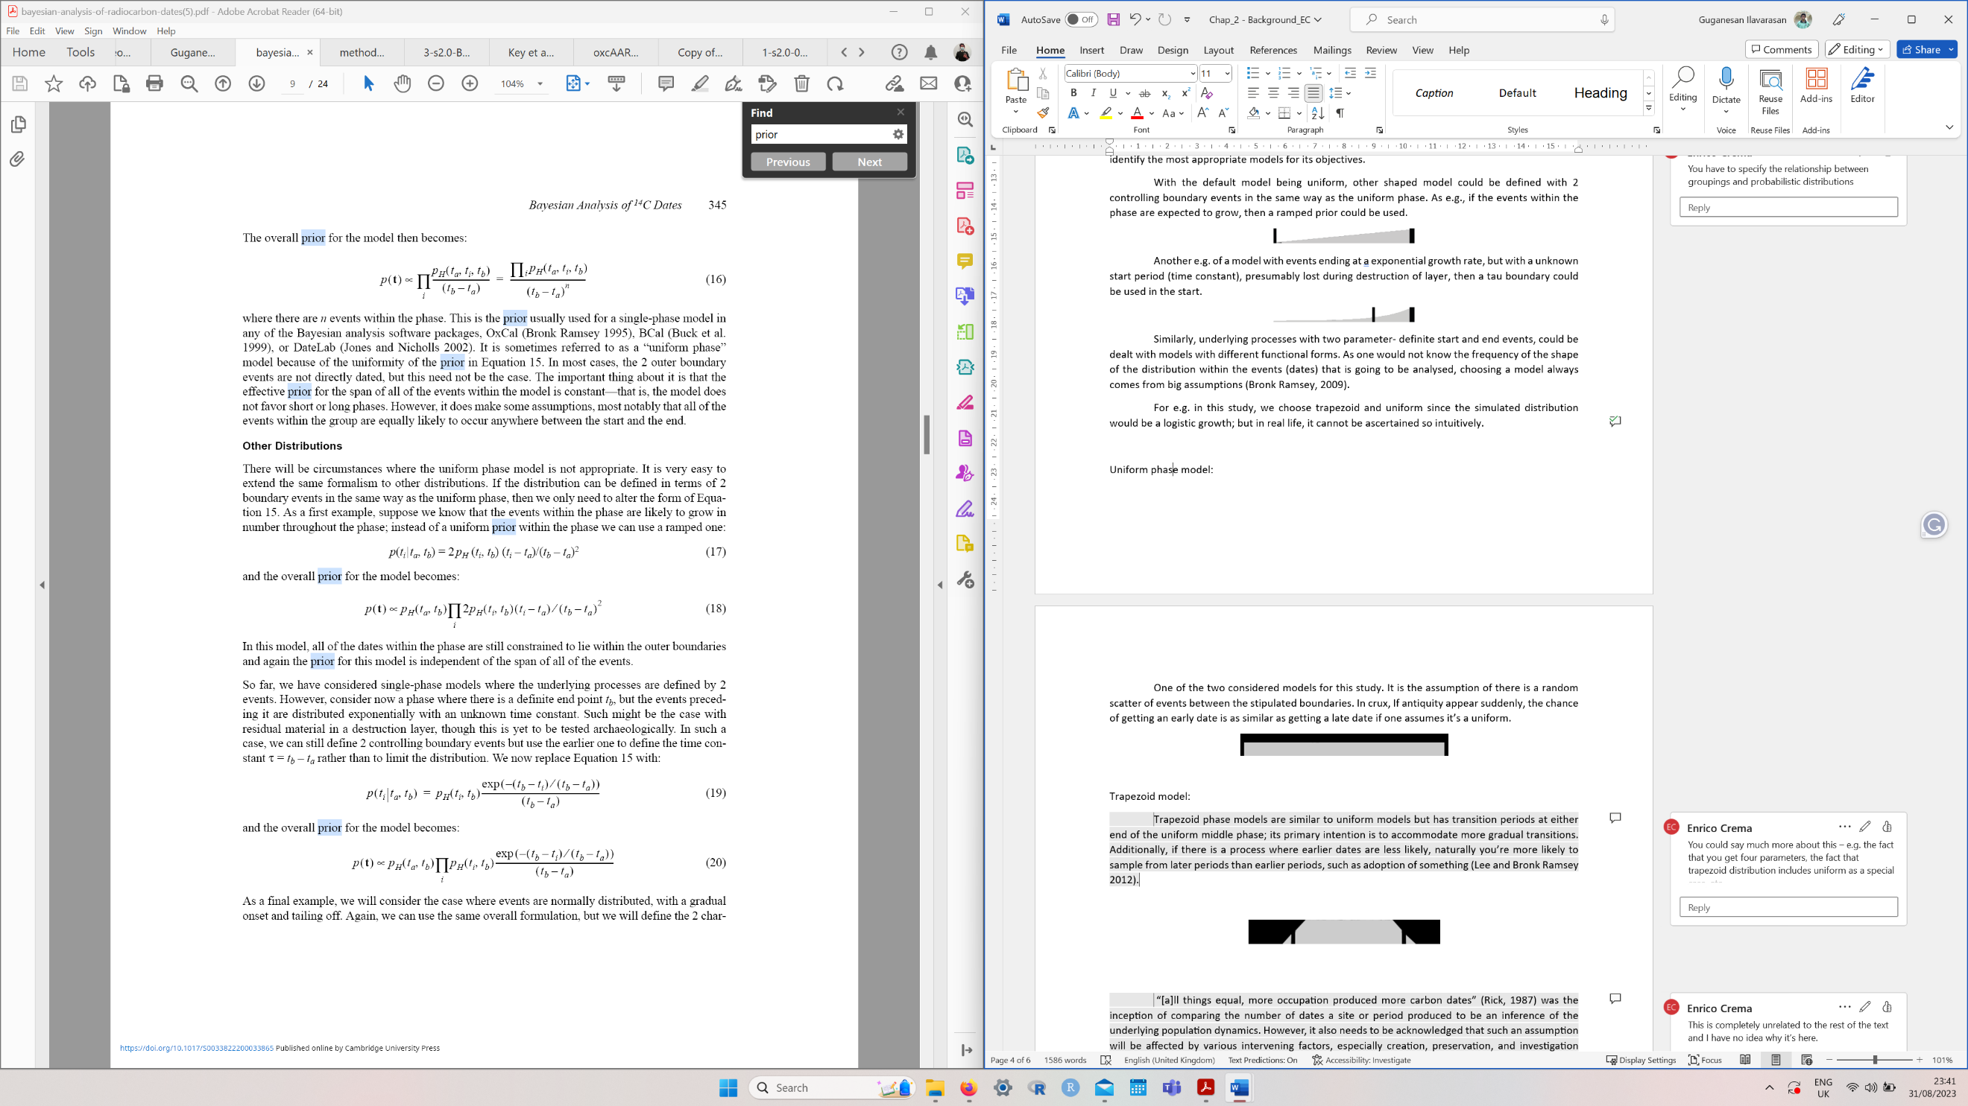

Trapezoid model:

Trapezoid phase models are similar to uniform models but have transition periods at either end of the uniform middle phase; its primary intention is to accommodate more gradual transitions (Figure 5). Due to its composition of the four phases, the model requires four parameters. This model would suit archaeological situations with a slow start and end to a phase.

Further, in a process where earlier dates are less likely to be found, which happens in many archaeological contexts, you are more likely to sample from later periods than earlier periods, such as adopting something (Lee and Bronk Ramsey 2012). Thus making trapezoid one of the most appropriate OxCal models for this study.

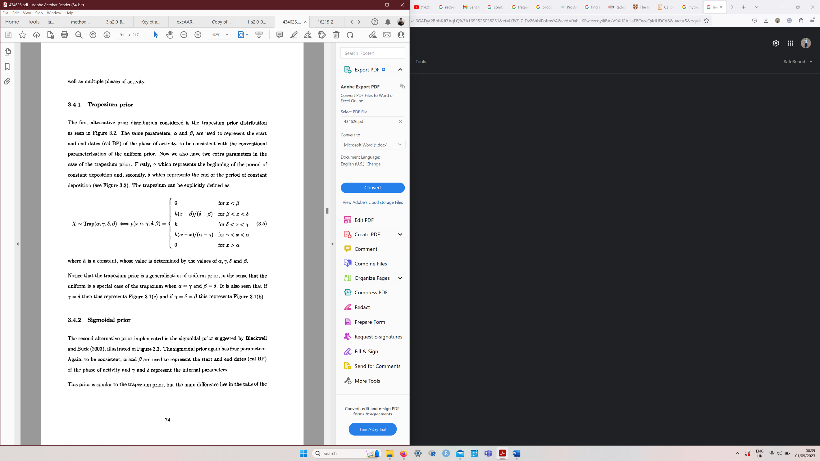

(Karlsberg 2006)

Optimal Linear Estimation (OLE):

OLE, a frequentist method, was initially developed for palaeontology. It has been accommodated into archaeology for origination estimation studies by reversing its original extinction prediction model. As part of the study, it was tested how robust an alternative approach the method is to Bayesian methods in archaeology. OLE utilises chronological occurrence and spacing of known archaeological phenomena to statistically estimate how much earlier or longer the event will likely have existed beyond the current known archaeological date (I. Djakovic et al., 2022).

*T*1>*T*2>...>*Tk* be the *k* most recent sighting times of a phenomenon, ordered from most recent to least recent. The extinction time, θ, is estimated using this record.

In this context, OLE is based on the result that the joint distribution of the *k* most recent sighting times has (roughly) the same ‘Weibull form’, regardless of the original distribution of the complete sighting record. Briefly, the optimal linear estimator of θ has the form of a weighted sum of the sighting times, calculated as $$\hat{\text{θ}}=\sum_{i=1}^{k}{aiTi}$$

(Roberts and Solow, 2003)

Unlike OxCal, OLE does not have any innate assumptions about the events’ composition/spread within the phase as it does not have any prior, which is slightly advantageous. This avoids the demand of choosing a matching (prior) ‘model’ based on your events’ distribution to model them efficiently. However, OLE does not run on radiocarbon ages, which should also be considered.

Challenges

OLE demanded more challenges to be countered than OxCal by making methodological alterations in how the approach yielded its results. This is mainly due to the different data requirements in the two approaches and OLE not accounting for measurement error. The whole framework around the elemental OLE() function, especially the input feeding routine, had to be drastically altered to replicate OxCal as much as possible.

OxCal was built to calibrate radiocarbon dates and handle associated functions like summarisation for technological origination studies. Meanwhile, OLE was designed to only take in discreet calendar dates as its input (unlike calibrated dates with a probability density function [PDF]), which is one of the main challenges of the method. So it makes much sense to make OLE perform as much as possible to the functionality and standard equivalent of OxCal rather than the other way around.

Accordingly, multiple suggested improvisations to the original OLE method are discussed below, primarily dealing with how dates are input. Attempts were made to introduce elements of uncertainty in the dates to mimic the calibrated dates’ PDF, along with experimentations on effective results retrieval and their systematic classification.

Why are challenges addressed only now?

Some significant studies with OLE in archaeology were done on hominins (Key and Ashton, 2023), except for a few on radiocarbon ages (Bebber and Key, 2022). So, the original inputs were not radiocarbon ages as the dates reported are much older, and radiocarbon applications only apply to those as old as 55,000 BP (Koppes and Lerner, 2023). So, the uncertainty of calendar time was not factored in to account for the calibrated difference.

Consequently, when considering the use of OLE for radiocarbon ages, the whole current discussion revolved around the sExtinct package (sExtinct, 2012) and OLE in particular, as they were not built to handle the uncertainty with the calendar dates and the associated calibrated confidence interval. So, there should be a structural alteration to OLE’s input process to input radiocarbon dates.

OLE’s inefficiency in running radiocarbon ages- pre-processing:

One efficient method that could be employed is to calibrate the radiocarbon age produced from the random generator (explained in methodology) to get a calendar date and extract the median of the calibrated calendar date, ignoring chronological uncertainty. This study achieves this by utilising a rcabon function, medCal().

Further, this newly generated median of the calendar date should be different from the originally sourced calendar date. It will never be replicated to the original date as there will always be an offset between the two because of a phenomenon discussed in the later chapters- the effect of calibration. Primarily depending on where you are on the calibration curve, the newly derived median of the post-calibrated calendar date could be close to the source true date, or it might be very distantly apart, and the influence of this effect drastically changes depending on the error associated to the dates and the shape of the relevant portion of the calibration curve.

However, a second approach might be formulated using a rcabon function, grids. After a date is calibrated, the function produces the probabilistic density value for all the calendar dates (calBP column) within the calibrated date’s highest posterior density interval-HDPI (PrDens column) (Figure 6). From this, a calendar date is randomly sampled from the calibrated probability distribution, with sample()using PrDens as values of probability weights in its probs parameter (Figure 7).

The function OLE() returns a true estimate, an upper confidence limit and a lower limit (Figure 8). Therefore, if you replicate the above sampling for 1000 iterations, 1000 OLE true estimates will be generated, which can later be collated, and a distribution of OLE estimates could be created. From this distribution, the 95% quantile interval could be retrieved. So, if this is repeated for the entire analysis, it would be 1000 iterations for 100 different sets of dates, thus 1,00,000 whole varied results.

However, this conceals an imperative issue; though this rectifies the chronological uncertainty that the previously suggested method of retrieving the median of the calibrated calendar date lacks, it does not solve the problem of sampling error: the confidence intervals are not combined. More descriptively, effectively, the confidence intervals generated for every output of OLE estimation of the sample are not accounted for during the iterations, as just the true estimate OLE$Estimate is taken for the distribution to extract the 95% percentile interval of the estimates.

Sampling and limitations:

The confidence interval produced by OLE is only a boundary value, and they do not have an inherent distribution like Bayesian’s *posterior*. So, despite having multiple confidence intervals from OLE runs, the derived $lowerCI and $upperCI aren’t intended to be combined or collated.

The building up of a distribution of true estimates and extracting their 95% percentile interval does not quite convey how the uncertainty comes from each of the estimates. OLE is not designed to account for measurement error, and the solution devised here addresses this, but at the expense of not accounting for sampling error.

Compromises with both methods:

There are different kinds of compromises with both methods, the median date approach [using medCal()] and the resampling approach (by grids extraction); the question is which one would be more of an issue if one is looking forward to avoiding it. If one is to deal with a relatively small sample number of dates, both methods are reasonably compliant to get the results back without much concern.

The sampled date through the grids method would change every time through the iteration, as it considers the entire distribution, returning a highly likely date. Whilst the non-iterative medCal approach would generate the result on a single date.

Confidence interval and OLE

Mathematically speaking, both methods are to be critiqued as they are not comparable to Bayesian inference, where posterior estimates are combinable. It is an innate character of OLE which cannot be solved on any improvisations, as OLE$upperCI and OLE$lowerCI are only margins of a confidence interval and do not represent any distribution of mediate values between them, as it is a flat, normal distribution.

Solutions?

Though combining confidence intervals in OLE is mathematically inappropriate, as suggested earlier, one solution is building a distribution of OLE$Estimate and taking its 95% quantile. It is not all right to accept this limitation as this disturbs the results when comparing various sample sizes. There would be a distinction of influence of uncertainty between an OLE estimate generated with five dates and 100 dates. Since the former would be plagued with much uncertainty due to a smaller sample size than the latter.

A couple of other methods in ‘*combining’* the OLE confidence intervals were devised, assuming the distribution between the generated OLE$upperCI and OLE$lowerCI margin is uniformly spread or a Gaussian. They were both mathematically incorrect, thinking the latter might be fine in some cases, but one cannot assume the shape of the distribution within the confidence interval; hence, they were disregarded.

Methodology

In brief, the study will involve simulating calibrated calendar dates and subjecting them to be run by a Bayesian phase model **(OxCal**) and OLE under different variables to represent different sample sizes (**n**) and rates of adoption (**r**) – the pace at which a technology is adopted and practised in a society, diffusion of an innovation.

Further, considering all the challenges discussed earlier, OLE and OxCal were improvised to take in the same randomly generated calendar dates from a sample generator (enumerated shortly). Then, they generate a predicted true start date with similar kinds of methodological workings accounting to incorporatable level of uncertainty. The OLE methods exercised here have been altered to be radiocarbon age-compatible models by accommodating chronological and sampling uncertainties.

Moreover, Bayesian models try to infer parameters (mean and Std Dev) of a distribution based on its shape. This emphasises the importance of the correlation between the distribution of the events (dates) and the OxCal model chosen to run the analysis, as it influences OxCal’s results.

Therefore, if we infer the suitable distribution, OxCal might produce more accurate and precise results than OLE. So, the methodology also includes experimenting with all the relevant OxCal models to infer the most consistent and the unsuitable models for each given adoption rate x sample size combination.

This is done based on us knowing the spread of the data since we simulated it, whilst in real-world data, we could not possibly know the data’s distribution. So, in the end, the study could suggest the most fitting OxCal model for different adoption rates and sample size combinations.

Research design

In the simplest of terms, the study primarily involves comparing the two methods, OxCal and OLE, and their four approaches (OxCal Trapezoid, OxCal Uniform, OLE Median and OLE Resampling) by their efficiency and potential to provide better results. Which will be based on passed input data: calendar dates (whose simulation will be briefed shortly), under a conditional generation influenced by two passed parameters- sample size and rate of adoption.

Accordingly, to ascertain the models’ performance at varied sample sizes and diffusion rates, these parameters are incremented systematically to observe the difference in the model’s results. Correspondingly, the results are gauged through their accuracy, precision, and distance from the start, all enumerated individually below.

Sample generation - Parameters:

Sample size (s)

The sample size was parameterised as a contextual representation of the number of radiocarbon ages procured from a site. By concept, it is understood that the number of radiocarbon ages yielded in a site is proportionate to the number of inhabitants lived in the same. “[a]ll things equal, more occupation produced more carbon dates” (Rick, 1987) was the inception of comparing the number of dates a site or period produced to be an inference of the underlying population dynamics.

Accordingly, three different sample sizes were decided to be used, namely 10, 50 and 100 dates, each symbolising that many people adopting the technology. The sample size variation feature was incorporated in this study as it would influence the models on the principle that fewer people doing farming would result in less evidence (radiocarbon ages). Thus, the earliest date among them is less likely to be closer to the actual start date, and the converse is true for more dates.

Rate of adoption (r)

The second crucial parameter is the diffusion rate, the rate at which a technology is getting accepted and used widely within the community- sigmoid diffusion curve. The probability of getting the earliest start date would differ in different distributions (e.g., normal, uniform, exponential, etc.), so a cumulative distribution function of a logistic feature is used to represent a technology’s growth and saturation (Crema and Shoda, 2021).

A steeper ‘S' curve would reveal a faster adoption, while a slower adoption would result in a gradual climb of the curve. This variation is controlled by providing a range of rates- 0.1, 0.05, 0.01; from which random dates are generated; the higher the number, the faster the adoption rate. This is achieved through nibleCarbon package’s rLogisticGrowth() function.

Simulation model

Therefore, both the models are fed with radiocarbon ages, which are derived by running the rLogisticGrowth() function with a specified start date of 5000 BP and an end date of 3000 BP and a rate of adoption, which then generates a list of random dates (radiocarbon ages) to the length of specified sample size by using the replicate() function (Figure 9).

Finally, all nine combinations are intended to run 100 iterations for every approach, providing more data to analyse. This will aid in giving a comprehensive outlook with enough contingency before making an assumption, as their averages will probably be fairly robust to consider.

Estimating Origination Date - OxCal

Unlike OLE, OxCal’s approaches were straightforward. Since the implicit goal was to make OLE run and output similar to OxCal, minimal alterations were made to OxCal in deriving the results. Of all OxCal models, *uniform* and *trapezoid* were considered due to their prior shape, which might be more suitable for tracing technological origination than other models and thus could be more appropriate to model growth and sustenance. The trapezoid model is expected to be more accurate than uniform in catching start dates at a lower rate of adoption due to the tapered shape at its either end, which constricts the radiocarbon ages’ likelihood distribution in the posterior. The Trapezoid also acts as a uniform model when conditions are a=b and c=d at the points of transition (figure 5).

Both models are very similar in running the analysis and returning the results; both (and the OLE approaches) are fed with the same randomly generated radiocarbon ages. By design, the dates are passed into a function oxcalScriptGen(), part of a custom module named oxcalScript.R (Crema, E.R., Kobayashi, K., 2020), which helps to generate OxCal scripts in *gaussian, uniform* and *trapezoid* models. Since OxCal analysis runs on its own proprietary script, the oxcalScriptGen() takes in the generated random dates, error margin and the type of desired models and outputs their OxCal code, which would help run OxCal from R. The outputs are saved in the local directory as .OXCAL files, which look like in Figure 10.

Followingly, the .OXCAL scripts are prepared to be read back and run through OxCal. The base R command, readLines() reads in the earlier generated .OXCAL files in, and a package called oxcAAR() is used to run the OxCal application from R (oxcAAR, 2021). oxcAAR() runs OxCal on the read scripts and saves the OxCal outputs into readable .JS and .XML temp files.

The executeOxcalScript() function of oxcAAR() is responsible for executing the OXCAL script, which generates a temporary JavaScript code, .JS file, with the OxCal results of all dates’ posterior distributions through Markov Chain Monte Carlo (MCMC) simulations (Appendix 1).

From this generated text output (refer to appendix: 1), the posterior estimates of the beginning phase of the OxCal models are retrieved using oxcAAR()‘s readOxcalOutput(). The start phase should ideally encompass the calibrated radiocarbon ages’ start date- the date of origination.

The start date retrieval is where the methods differ by models. The uniform model has no distinction of different phases within the continuum of its temporal scale: it is a single uniform phase. Therefore, the start phase posterior of the whole model is called to be recovered. So, from the model’s Start Phase, Phase and End Phase, the Start Phase’ predicted 95.4% posterior is taken as the true start date.

Meanwhile, the trapezoid model is a tri-phased distribution with one uniform phase bounded by two sloping triangular phases, to mimic the most certain technological adoption scenario. So, the model generates start phase posterior values for each phase- Start Phase, Phase and End Phase. The Start Phase‘s Start of Start Phase is taken as the true start date.

After retrieving these results (Appendix 2), they are cleaned of miscellaneous texts to derive just the numbers of posterior value, e.g. 3418 and 2881 in the uniform model in Appendix 2. Two custom scripts, oxcalcleaner.R and oxcalcleanerunif.R, are designed to do this; the former is for cleaning the trapezoid model’s outputs, and the latter is for uniform. The filtered outputs of readOxcalOutput are segregated according to number of lines in them when passed into the cleaners.

The minimum is three indices- two lines of descriptive metatext, i.e. line #740 and #741 in Appendix 2’s trapezoid output, and the third line, #748, is the date to be extracted. The number of lines that need to be cleaned varies every run due to the varying composition of the 95.4% probability density, depending on its split between in the multi-modal OxCal posterior distribution.

To accommodate this, oxcalcleaner.R and oxcalcleanerunif.R possess multiple cleaning modules that handle OxCal distribution split into two ways to a maximum of four. Thus, the main cleaners receive and pass the outputs to respective sub-cleaners based on their indices length. Methodologically, both cleaners for the different models' results work similarly, with the distinction of just how many lines of results are passed into them.

Apart from cleaning the text outputs, the cleaners also calculate the precision, accuracy, and distance from the start on the cleaned dates and append them to a data frame in the global environment. This results repository is then used to perform comparative analysis.

Challenges with OxCal:

The executeOxcalScript() function does most of the modelling by running OxCal from R and then deriving back the initial results, which are then cleaned. Also, its processing time takes much time due to MCMC requiring longer to compute. This would discourage running multiple simulation runs on the sample size, which currently is aimed to be 100 runs per combination of rate of adoption and sample size, which might take days to complete. Therefore, a parallelisation approach was used within the OxCal method (Appendix 3).

OLE - OLE Using Median Calibrated Dates:

The method converts the randomly simulated calendar dates to radiocarbon ages and calibrates them with the same error rate assigned to OxCal. The median of the calibrated date distribution is chosen to return the confidence interval margins- OLE$upperCI and OLE$lowerCI, from which its precision and accuracy are calculated.

One concern with the method could be when there is a case of a multi-modal distribution, which is likely to be a case with a calibrated date. There will be peaks and troughs, with peaks having the highest likely HDPI value than the troughs. However, since medCal only chooses the medians, there is a chance the median lies in a trough, which is selected to run the OLE analysis.

OLE grids confidence interval method:

The sample variation method contrasts the single date-driven median approach. A 95% most significant quantile interval of a distribution of OLE$Estimates is derived by repeated sampling of a single date from every calibrated probability distribution and running an OLE analysis on it for 1000 iterations. This provides a start and end interval of a range, which is then used to calculate the precision and accuracy.

Evaluating Robustness

After ensuring that there are no NA values, the results of the different approaches are evaluated using three vital indicators: precision, accuracy and distance from the start, calculated at the end of the cleaners’ modules- margin, accuracy and distancefromstart.

Precision:

The absolute difference between the two dates is calculated, which would effectively give a range, which is the precision/prediction interval of the result of the model (Figure 11). Unlike OxCal, where the precision calculation is done in the cleaner modules, for the OLE methods, accuracy, precision and distance to start are derived within the respective OLE modules.

Accuracy:

The true start date is known to be 5000 BP, which would be a benchmark to test the results. Accordingly, a Boolean-binary approach marked the Accuracy by using the between() function from the dplyr package (dpylr, 2023). A conditional if statement has been built, where if the particular result has the true start date included within its margin, then it activates a counter, thus incrementing the object accuracy’s value to 1; accuracy’s value is reset back to 0 at the start of the next iteration (Figure 12).

Distance from start:

The distance from the start was obtained for in-accurate results by calculating the shortest distance between the true origination date and the margins of the confidence interval(s). Since the confidence intervals could be split into multiple intervals, due to the multi-modality of the PDF, one could have a lower distance from the start value than the other.

Further, it cannot be assumed that the start date will always be closer to the true start (under-quoted interval), e.g. for 5436 – 5109, the overquoted margin has its end date closer to the true start date. Therefore, all the divided envelops of a confidence interval’s start and end dates are subtracted, and the least of all estimates is chosen through minimum() to find the closest margin to 5000 (Figure 13).

After generating all three different values, they are joined into a single matrix exported to be appended as a new row into the original results-gathering data frame, e.g., trap_df (Figure 14).

Inferring results:

There is a consideration of duality when comparing precision and accuracy. A model could suggest extremely precise margins but consistently prove to be inaccurate; on the other hand, they could be accurate every single time, but the precision could be centuries long. So, high uncertainty is a consequence to avoid as it is not informative; meanwhile, the chance of being inaccurate is also extremely high when completely negating uncertainty and predicting an extremely narrow margin.

Therefore, there is always a trade-off of uncertainty, so when comparing two models, the best model for a particular setting of the rate of adoption and sample size will be the one that can predict the highest precision by giving out a relatively narrow interval, but also which would be more accurate. So, it would be interesting to compare all the four different approaches, as there should not be an expectation that OLE is better in a certain combination and vice versa for OxCal. However, given the combination, OLE could be systematically more precise but less accurate.

Therefore, the end objective would be to generate guidance, and not that much of a prescriptive method should be preferred over the other directive. However, it would be a suggestive interpretation of which strategy to follow and the advantages of one over the others.

Troughton:

A server computer was planned to be utilised as the computational demand of this study exceeds that of a conventional personal computer (Figure 15). Consequently, the Computational and Digital Archaeology’s (CDAL) Troughton computer was requested access to run all the analysis. Troughton, an Ubuntu-running server, has 96 cores-based Intel Xenon processors and 128 gigabytes of RAM.

Preliminary expectations:

Trapezoid model’s advantage at a slower adoption rate:

The uniform model assumes all the dates are scattered randomly between the start and end date, with each date having the same probabilistic density, thus considering them uniformly distributed. Hence, in comparison, the model should be less accurate at a lower rate of adoption; due to the Trapezoid’s sloped start phase, it constricts the dates much tighter, resulting in the generated start dates falling closer to the true start date, i.e., 5000 BP.

OLE grids method should be more accurate:

Depending on the sample size, the medCal approach is less likely to be better than the grids method as it generates its OLE result based on a single (median) date (from a calibrated calendar date’s distribution) whilst grids factors in a 1000 different scenario of the same date under the calibrated probability density curve. Further, the medCal method’s outputs are the confidence intervals generated from the OLE() function, OLE$upperCI and OLE$lowerCI, whilst the grids methods results are generated from OLE$Estimate, the true estimate value.

So, medCal might be more precise, predicting a tighter margin since it is not affected by *noise* as it runs with just a single date, thus resulting in less distortion. However, in terms of accuracy, having the original start date within its margin, the grids method should have an edge, as it considers 1000 samples to arrive at its estimate.

List of Figures:

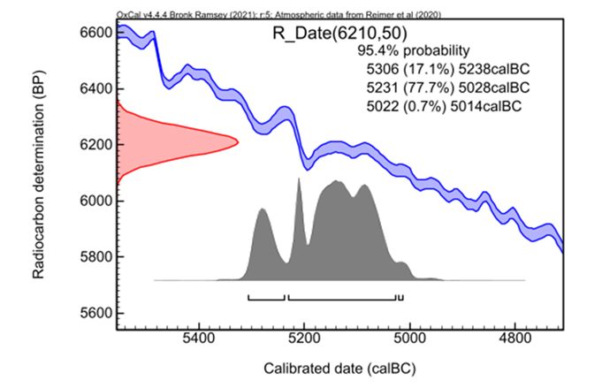

Figure 1: Calibrated Radio-carbon age (BP) to Calendar date (BCE)



Figure 2: A ramped prior.



Figure 3: An exponential prior with an unknown start.



Figure 4: A uniform prior



Figure 5: A trapezoid prior

$grids$`1`

calBP PrDens

1 4852 1.054263e-05

.

127 4726 9.170248e-03

.

276 4577 1.412731e-05

Figure 6: Result of grids

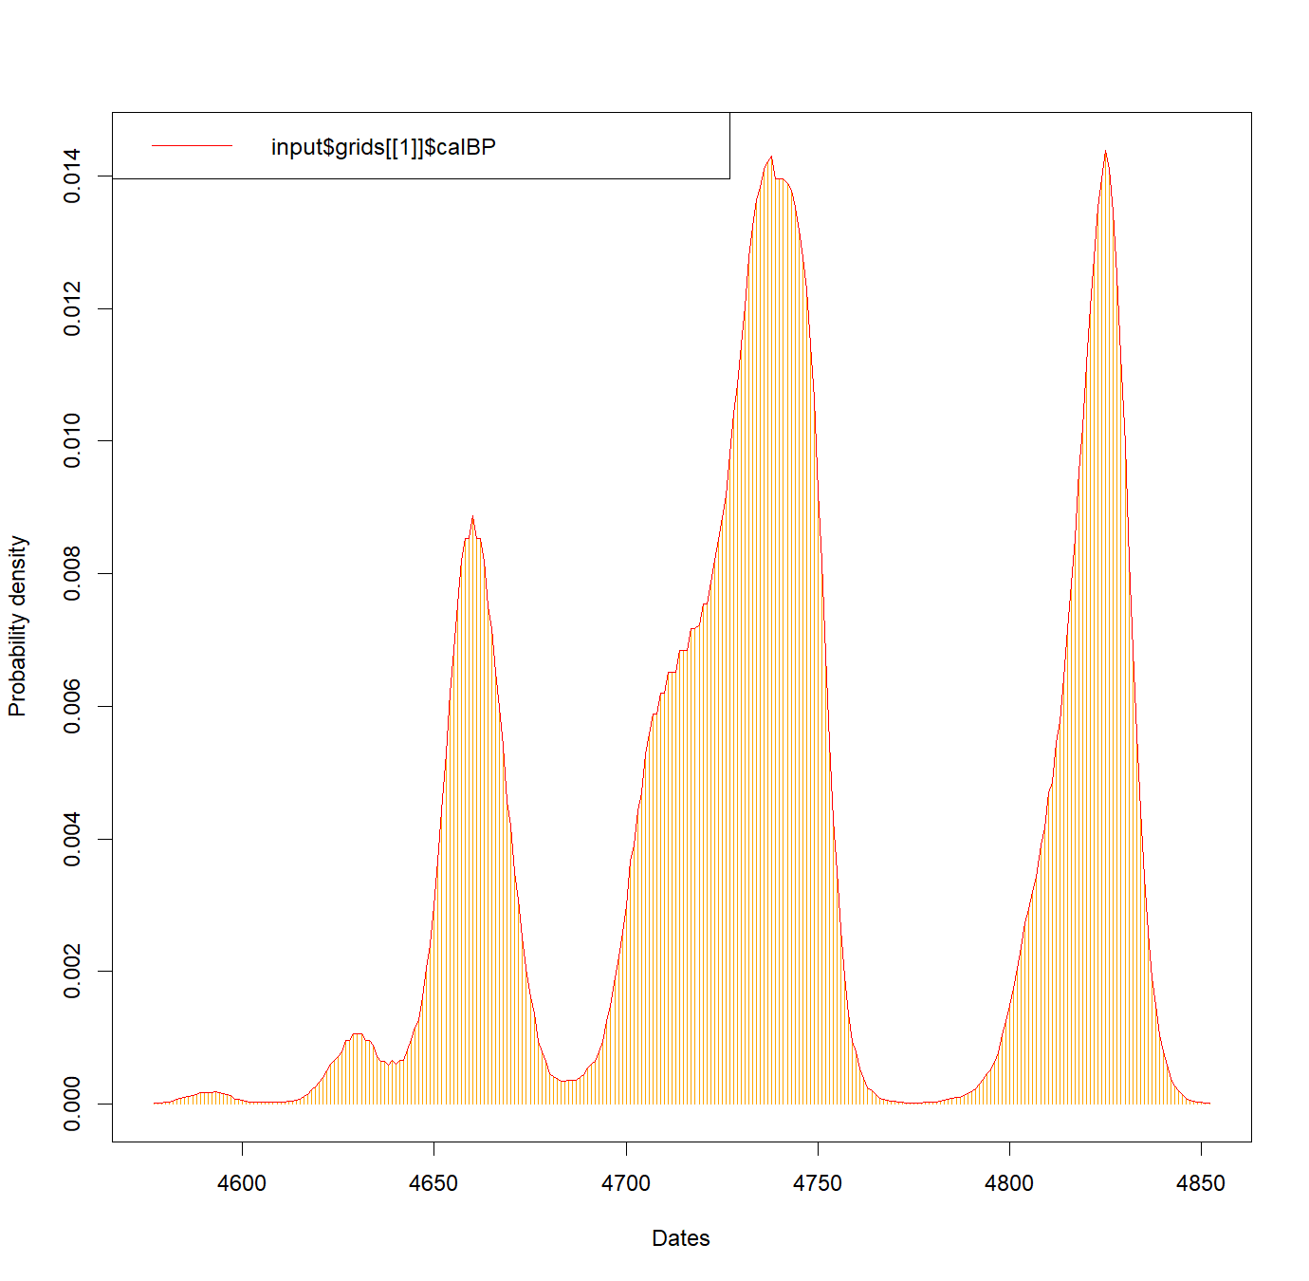

Figure 7: Plot of grids’ output

> OLE(data.frame(sampledinput,rep(1,length(sampledinput))),alpha=0.05)

$Estimate

[1] 4737.99

$lowerCI

[1] 4737.964

$upperCI

[1] 4738.205

attr(,"class")

[1] "extmod"

attr(,"row.names")

[1] 1

Figure 8: Output of OLE()

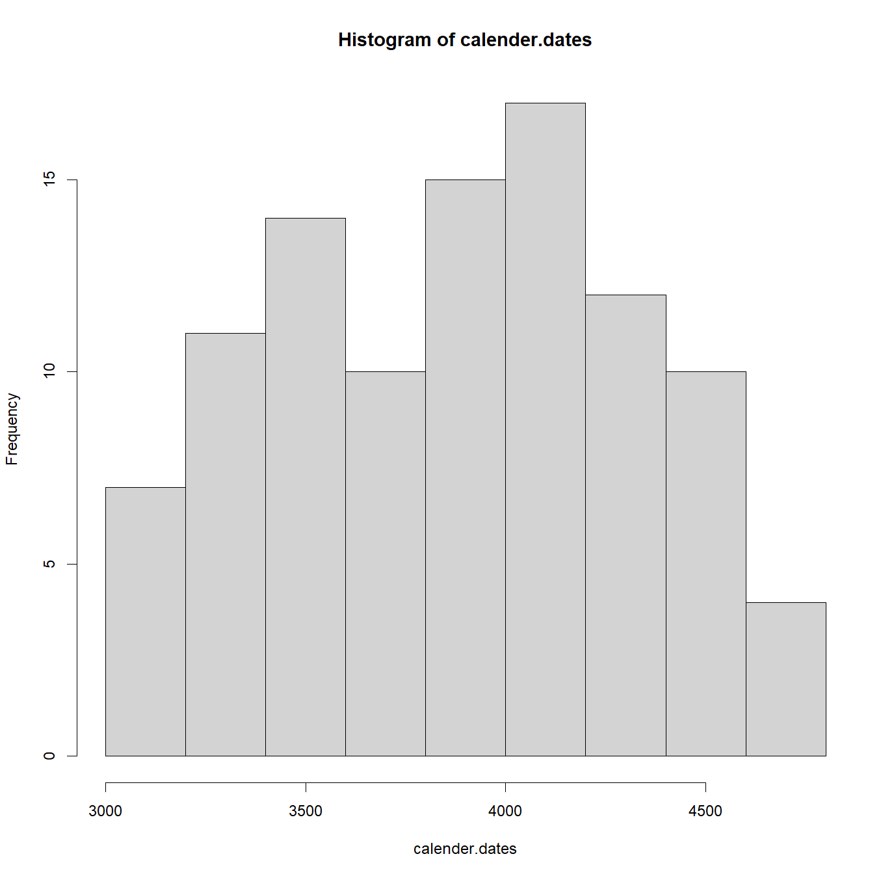 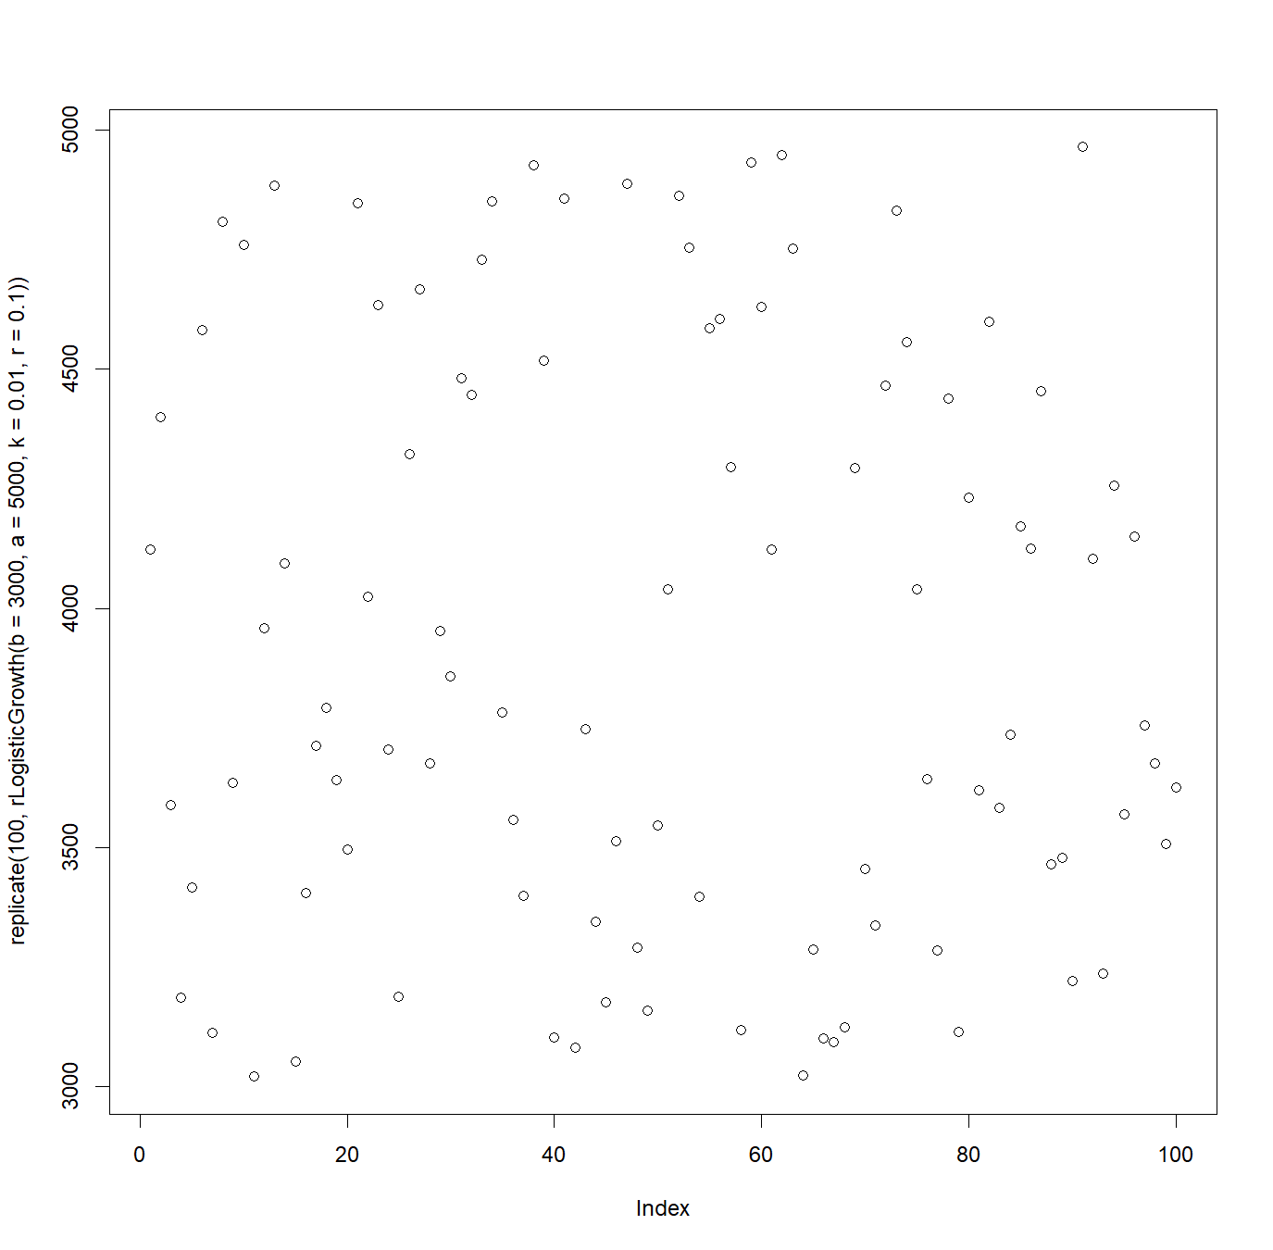

Figure 9: Histogram and true shape of distribution plot of n = 100 and r = 0.01

|  |  |
| --- | --- |
| Uniform model | Trapezoid model |
| Options(){Resolution=5;SD1=FALSE;SD2=TRUE;BCAD=FALSE;};  Plot(){  Phase(){  Sequence(){  Boundary("Start Phase");  Phase("Phase")  {  R_Date("id1",2869,20);  R_Date("id2",2922,20);  R_Date("id3",3329, 20);  R_Date("id4",3678, 20);  R_Date("id5",3716, 20);  R_Date("id6",3735, 20);  R_Date("id7",3786, 20);  R_Date("id8",3890, 20);  R_Date("id9",3907, 20);  R_Date("id10",3976, 20);  };  Boundary("End Phase");  };  };  }; | Options(){Resolution=5;SD1=FALSE;SD2=TRUE;BCAD=FALSE;};  Plot(){  Phase(){  Sequence(){  Boundary("Start Phase"){  Start("Start of Start Phase");  Transition("Period of Start Phase");  End("End of Start Phase");  };  Phase("Phase")  {  R_Date("id1",3051,20);  R_Date("id2",3126, 20);  R_Date("id3",3213, 20);  R_Date("id4",3263, 20);  R_Date("id5",3637, 20);  R_Date("id6",3682, 20);  R_Date("id7",3864, 20);  R_Date("id8",3890, 20);  R_Date("id9",3890, 20);  R_Date("id10",4143, 20);  };  Boundary("End Phase"){  Start("Start of End Phase");  Transition("Period of End Phase");  End("End of End Phase");  };  };  };  }; |

Figure 10: Snippet of OxCal run scripts for both models

time.s32 <- rngrangesplit32_num_noNA[1] #predicted start date

time.e32 <- rngrangesplit32_num_noNA[3] #predicted end date

margin <- time.s32 - time.e32

# for intervals with four different envelopes

if (range32 == "TRUE" || range42 == "TRUE"|| range52 == "TRUE" || range62 == "TRUE")

{

accuracy <- accuracy + 1

}

margin32 <- time.s32 - time.e32

margin42 <- time.s42 - time.e42

margin52 <- time.s52 - time.e52

margin62 <- time.s62 - time.e62

margin <- + margin62 + margin52 + margin42 + margin32

Figure 11: Snippet to calculate precision from OxCal outputs

accuracy <- 0

# Define value

x1 <- 5000

# Define lower bound

left1 <- time.e32

# Define upper bound

right1 <- time.s32

# Apply between function

range32 <- between(x1, left1, right1)

# print(range32)

if (range32 == "TRUE")

{

accuracy <- accuracy + 1

}

Figure 12: Snippet to calculate accuracy from OxCal outputs

distancefromstart <- 0

if (accuracy == 0){

distancefromstart <- min(c(abs(5000 - rngrangesplit32_num_noNA[1]),abs(5000 - rngrangesplit32_num_noNA[3])))

#for four way split intervals

#distancefromstart <- min(c(abs(5000-rngrangesplit32_num_noNA[1]),abs(5000-rngrangesplit32_num_noNA[3]),abs(5000-rngrangesplit42_num_noNA[1]),abs(5000-rngrangesplit42_num_noNA[3]),abs(5000-rngrangesplit52_num_noNA[1]),abs(5000-rngrangesplit52_num_noNA[3]),abs(5000-rngrangesplit62_num_noNA[1]),abs(5000-rngrangesplit62_num_noNA[3])))

}

Figure 13: Snippet calculating Distance from start in cleansix.R

new_row <- c(margin, accuracy, distancefromstart)

trap_df[nrow(trap_df) + 1, ] <<- new_row

Figure 14: Snippet to retrieve accuracy, precision and distance from start for every result.

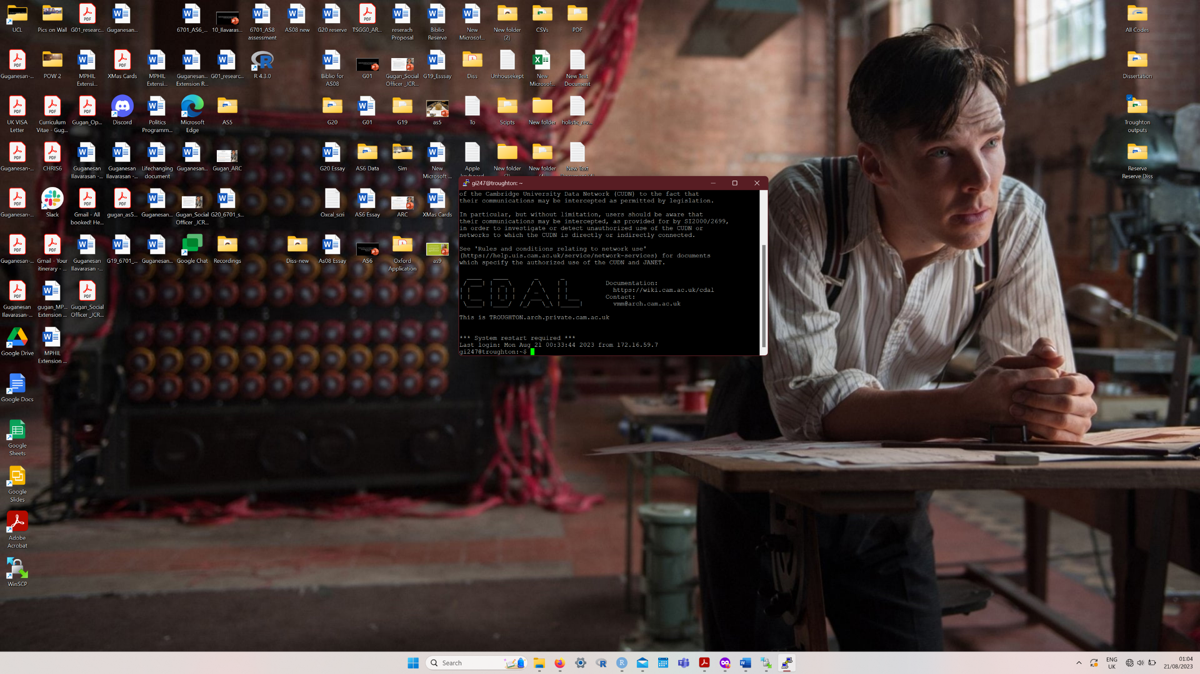

Figure 15: Troughton terminal

Bibliography:

Alastair J.M. Key, David L. Roberts, Ivan Jarić, Statistical inference of earlier origins for the first flaked stone technologies, Journal of Human Evolution, Volume 154, 2021, 102976, ISSN 0047-2484, <https://doi.org/10.1016/j.jhevol.2021.102976>.

Alastair Key, A., & Nick Ashton, (2023). Hominins likely occupied northern Europe before one million years ago. https://doi.org/10.17863/CAM.90847

Bayliss, A., Marshall, P., Dee, M., Friedrich, M., Heaton, T., & Wacker, L. (2020). IntCal20 Tree Rings: An Archaeological Swot Analysis. Radiocarbon, 62(4), 1045-1078. doi:10.1017/RDC.2020.77

Bebber, M., & Key, A. (2022). Optimal Linear Estimation (OLE) Modeling Supports Early Holocene (9000–8000 RCYBP) Copper Tool Production in North America. American Antiquity, 87(2), 267-283. doi:10.1017/aaq.2021.121

Bevan, A., Colledge, S., Fuller, D., Fyfe, R., Shennan, S., & Stevens, C. (2017). Holocene fluctuations in human population demonstrate repeated links to food production and climate. Proceedings of the National Academy of Sciences, 114(49), E10524–E10531. https://doi.org/10.1073/pnas.1709190114.

Bird, D., Miranda, L., Vander Linden, M., Robinson, E., Bocinsky, R. K., Nicholson, C., Capriles, J. M., Finley, J. B., Gayo, E. M., Gil, A., d’AlpoimGuedes, J., Hoggarth, J. A., Kay, A., Loftus, E., Lombardo, U., Mackie, M., Palmisano, A., Solheim, S., Kelly, R. L., & Freeman, J. (2022). p3k14c, a synthetic global database of archaeological radiocarbon dates. Scientific Data, 9, 27. https:// doi. org/ 10. 1038/ s41597- 022- 01118-7

Buck, C. E., Litton, C. D., & Smith, A. F. M. (1992). Calibration of radiocarbon results pertaining to related archaeological events. Journal of Archaeological Science, 19, 497–512. doi: 10.1016/0305-4403(92)90025-X.

Burley, David & Connaughton, Sean & Clark, Geoffrey. (2018). Early cessation of ceramic production for ancestral Polynesian society in Tonga. PLOS ONE. 13. e0193166. 10.1371/journal.pone.0193166.

Brunner, M., von Felten, J., Hinz, M., & Hafner, A. (2020). Central European Early Bronze Age chronology revisited: A Bayesian examination of large-scale radiocarbon dating. PloS one, 15(12), e0243719. <https://doi.org/10.1371/journal.pone.0243719>

Bronk Ramsey, C. (2009). Bayesian analysis of radiocarbon dates. Radiocarbon 51(1):337–60.

Bronk Ramsey, C., & Lee, S. (2013). Recent and Planned Developments of the Program OxCal. Radiocarbon, 55, 720-730. <https://doi.org/10.1017/S0033822200057878>

Bronk Ramsey, C. (2017). Methods for summarising radiocarbon datasets. Radiocarbon, 59(06), 1–25. https://doi.org/10.1017/RDC.2017.108.

Christen, J. A., Clymo, R. S., & Litton, C. D. (1995). A Bayesian approach to the use of 14C dates in the estimation of the age of peat. Radiocarbon, 37, 431–441. doi: 10.1017/S0033822200030915.

Crema, E.R., Kobayashi, K., 2020. A multi-proxy inference of Jōmon population dynamics using bayesian phase models, residential data, and summed probability distribution of 14C dates. Journal of Archaeological Science 117, 105136. DOI: <https://doi.org/10.1016/j.jas.2020.105136>

Crema, Enrico & Shoda, Shinya. (2021). A Bayesian approach for fitting and comparing demographic growth models of radiocarbon dates: A case study on the Jomon-Yayoi transition in Kyushu (Japan). PLOS ONE. 16. e0251695. 10.1371/journal.pone.0251695.

Crema, E. R. (2022). Statistical Inference of Prehistoric Demography from Frequency Distributions of Radiocarbon Dates: A Review and a Guide for the Perplexed. J Archaeol Method Theory 29, 1387–1418. <https://doi.org/10.1007/s10816-022-09559-5>

Diamond, J. 2005. Collapse: How Societies Choose to Fail or Succeed. New York: Viking.

Detect where values fall in a specified range, Function reference, dpylr. Accessed on 19/08/2023

<https://dplyr.tidyverse.org/reference/between.html>

Djakovic, I., Key, A., & Soressi, M. (2022). Optimal linear estimation models predict 1400-2900 years of overlap between Homo sapiens and Neandertals prior to their disappearance from France and northern Spain. Scientific reports, 12(1), 15000. <https://doi.org/10.1038/s41598-022-19162-z>

Koppes, Steve and Lerner, Louis. Carbon-14 dating, explained, The Day Tomorrow Began, University of Chicago. Accessed on 30/08/2023

<https://news.uchicago.edu/explainer/what-is-carbon-14-dating>

Fleiter, Tobias & Plötz, Patrick. (2013). Diffusion of Energy-Efficient Technologies. Encyclopedia of Energy, Natural Resource, and Environmental Economics. 1. 63-73. 10.1016/B978-0-12-375067-9.00059-0.

Friman, B., & Lagerås, P. 2022. From Neolithic Boom-and-Bust to Iron Age Peak and Decline: Population and Settlement Dynamics in Southern Sweden Inferred from Summed Radiocarbon Dates. European Journal of Archaeology, 1-21. <https://doi:10.1017/eaa.2022.43>

Hart, J. P. (2015). Review of Radiocarbon Dating: An Archaeological Perspective, Second Edition by R. E. Taylor and Ofer Bar-Yosef. Midcontinental Journal of Archaeology 40: On-Line Book Reviews.

Heaton, T. J. (2022). Non-parametric calibration of multiple related radiocarbon determinations and their calendar age summarisation. arXiv. https://doi.org/10.48550/arXiv.2109.15024

Introduction to Parallel Computing Tutorial, Livermore Computing: HPC at LLNL, Lawrence Livermore National Laboratory (LLNL) Accessed on 16/08/2023

<https://hpc.llnl.gov/documentation/tutorials/introduction-parallel-computing-tutorial>

Karlsberg, Angela Jane. “Flexible Bayesian methods for archaeological dating.” (2006).

Lagerås, P. ed. 2016. Environment, Society and the Black Death: An Interdisciplinary Approach to the Late-Medieval Crisis in Sweden. Oxford: Oxbow Books.

Man pages for oxcAAR, Interface to 'OxCal' Radiocarbon Calibration, R Package Documentation. Accessed on 29/08/2023.

<https://rdrr.io/cran/oxcAAR/man/>

McLaughlin, T. R. (2019). On applications of space–time modelling with open-source 14C age calibration. Journal of Archaeological Method and Theory, 26, 479–501. https:// doi. org/ 10. 1007/ s10816- 018- 9381-3

Menne, J. & Brunner, M. (2021). Transition from Swifterbant to Funnelbeaker: A Bayesian Chronological Model. Open Archaeology, 7(1), 1235-1243. <https://doi.org/10.1515/opar-2020-0191>

Parkinson, E.W., McLaughlin, T.R., Esposito, C. et al. (2021). Radiocarbon Dated Trends and Central Mediterranean Prehistory. J World Prehistory 34, 317–379. https://doi.org/10.1007/s10963-021-09158-4

Mishra, Priyanka. lapply() function, apply(), lapply(), sapply(), and tapply() in R, Geeks for Geeks. Accessed on 18/08/2023

<https://www.geeksforgeeks.org/apply-lapply-sapply-and-tapply-in-r/>

Moll-Elsborg, Jens. Getting Started With Parallel Programming In R, Dividing the work between multiple CPU cores, Towards Data Science. Accessed on 18/08/2023

<https://towardsdatascience.com/getting-started-with-parallel-programming-in-r-d5f801d43745>

Oehm, Daniel. Simple Parallel Processing in R, Gradient Descending. Accessed on 18/08/2023

<https://gradientdescending.com/simple-parallel-processing-in-r/>

Parkinson, E.W., McLaughlin, T.R., Esposito, C. et al. (2021). Radiocarbon Dated Trends and Central Mediterranean Prehistory. J World Prehistory 34, 317–379. <https://doi.org/10.1007/s10963-021-09158-4>

Plog, F.T. (1973). Diachronic anthropology. In C. L. Redman (Rd.), Research and theory in current archaeology (pp. 181-198). New York: Wiley.

Radiocarbon Calibration, OxCal. Accessed on 24/08/2023

<https://c14.arch.ox.ac.uk/calibration.html>

Radiocarbon Tree-Ring Calibration, Beta Analytic Accessedd on 31/08/2023

<https://www.radiocarbon.com/tree-ring-calibration.htm>

Reimer, P., Austin, W., Bard, E., Bayliss, A., Blackwell, P., Bronk Ramsey, C., Talamo, S. et al. (2020). The IntCal20 Northern Hemisphere Radiocarbon Age Calibration Curve (0–55 cal kBP). Radiocarbon, 62(4), 725-757. doi:10.1017/RDC.2020.41

Rick, J. W. (1987). Dates as data: An examination of the peruvian preceramic radiocarbon record. American Antiquity, 52, 55–73. JSTOR. doi: 10.2307/281060.

Ruddiman, W.F. 2003. The Anthropogenic Greenhouse Era Began Thousands of Years Ago. Climatic Change, 61: 261–293. <https://doi.org/10.1007/s10584-005-7278-0>

Rowley-Conwy, P. 2011. Westward Ho! Current Anthropology, 52: S431–S451. <https://doi.org/10.1086/658368>

sExtinct, CRAN, GitHub. Accessed on 30.08.2023

<https://github.com/cran/sExtinct/tree/master>

Sköld, M and Roberts. G.O. “Density Estimation for the Metropolis-Hastings Algorithm.” Scandinavian Journal of Statistics, vol. 30, no. 4, 2003, pp. 699–718. JSTOR, http://www.jstor.org/stable/4616797. Accessed 28 Aug. 2023.

Shennan, S., Downey, S.S., Timpson, A., Edinborough, K., Colledge, S., Kerig, T., Manning, K., Thomas, M.G., (2013). Regional population collapse followed initial agriculture booms in mid-Holocene Europe. Nature Communications, 4, ncomms3486. https://doi. org/10.1038/ncomms3486

Stevens, C.J. & Fuller, D.Q. 2012. Did Neolithic Farming Fail? The Case for a Bronze Age Agricultural Revolution in the British Isles. Antiquity, 86: 707–22. https:// doi.org/10.1017/S0003598X00047864

Taylor, R.E., & Bar-Yosef, O. (2014). Radiocarbon Dating: An Archaeological Perspective (2nd ed.). Routledge. https://doi.org/10.4324/9781315421216

Weston, Steve. Using the foreach package, foreach: Provides Foreach Looping Construct, The Comprehensive R Archive Network. Accessed on 17/08/2023

<https://cran.r-project.org/web/packages/foreach/vignettes/foreach.html>

Wang, C., Lu, H., Zhang, J., Gu, Z., & He, K. (2014). Prehistoric demographic fluctuations in China inferred from radiocarbon data and their linkage with climate change over the past 50,000 years. Quaternary Science Reviews, 98, 45–59. https:// doi. org/ 10. 1016/j. quasc irev. 2014. 05. 015

Warden, L., Moros, M., Neumann, T., Shennan, S., Timpson, A., Manning, K., et al. 2017. Climate Induced Human Demographic and Cultural Change in Northern Europe During the Mid-Holocene. Scientific Reports, 7: 1–11. https:// doi.org/10.1038/s41598-017-14353-5

What is Parallel Computing?, Parallel Computing Definition, Parallel Computing, Heavy.AI

Accessed on 16/08/2023

<https://www.heavy.ai/technical-glossary/parallel-computing>

What is SSH and how do I use it?, Information Services Division, University College London. Accessed on 20/082023

<https://www.ucl.ac.uk/isd/what-ssh-and-how-do-i-use-it>

Williams, A. N. (2012). The use of summed radiocarbon probability distributions in archaeology: A review of methods. Journal of Archaeological Science, 39, 578–589.

Appendix 1:

Output for a executeOxcalScript() trapezoid model (note: for n = 10 dates and only 95.4% value is taken)

Start of Start Phase Start()

Period of Start Phase Transition()

End of Start Phase End()

( Boundary Start Phase

Start Phase Boundary()

) Boundary Start Phase

id1 R_Date(3442,20)

95.4% probability

1876BC (19.0%) 1842BC

1823BC ( 6.2%) 1796BC

1780BC (69.9%) 1686BC

1649BC ( 0.4%) 1645BC

.

.

.

Posterior

( MCMC(30000)

Overall agreement 98.3%

Dynamic agreement 98.3%

Start Phase Posterior

95.4% probability

3571BC ( 0.1%) 3560BC

3554BC (95.3%) 2130BC

Start of Start Phase Posterior

95.4% probability

4387BC (95.4%) 2926BC

Period of Start Phase Posterior

95.4% probability

0 (95.3%) 2630

2663 ( 0.1%) 2674

.

.

.

End of Start Phase Posterior

95.4% probability

3335BC (95.4%) 1048BC

id1 Posterior

95.4% probability

1876BC (18.6%) 1842BC

1823BC ( 6.0%) 1796BC

1780BC (70.8%) 1684BC

Agreement 98.7%

.

.

.

End Phase Posterior

95.4% probability

1393BC (95.4%) 234BC

Start of End Phase Posterior

95.4% probability

2149BC (95.4%) 434BC

Period of End Phase Posterior

95.4% probability

0 (95.4%) 1918

End of End Phase Posterior

95.4% probability

1109BC (95.4%) 379AD

) MCMC(1920000)

As could be inferred, the first half of the executeOxcalScript() produced results brief about the likelihood calculation and the following half about the posterior determination after MCMC analysis. With the OxCal results now generated, the earlier generated .JS file’s content is derived using the readOxcalOutput() function. This reads in the original OxCal output format into a vector of strings, making it accessible to perform text analysis. With just strings as its content, readOxcalOutput() writes the OxCal output into an .XML file.

"x"

"1" "ocd[0]={};"

"2" "ocd[0].likelihood={};"

"3" "ocd[0].posterior={};"

"4" "ocd[0].likelihood.comment=[];"

"5" "ocd[0].likelihood.comment[0]=\"OxCal v4.4.4 Bronk Ramsey (2021); r:5\";"

"6" "ocd[0].calib=0;"

"7" "calib[0]={};"

"8" "calib[0].ref=\"Atmospheric data from Reimer et al (2020)\";"

"9" "calib[0].start=-53049.5;"

"10" "calib[0].resolution=5;"

.

.

.

"735" "ocd[3].posterior.convergence=97.1;"

"736" "if(!ocd[4]){ocd[4]={};};"

"737" "ocd[4].ref=\"OxCal v4.4.4 Bronk Ramsey (2021); r:5\";"

"738" "if(!ocd[4].name){ocd[4].name=\"Start of Start Phase\";}"

"739" "ocd[4].posterior={};"

"740" "ocd[4].posterior.comment=[];"

"741" "ocd[4].posterior.comment[0]=\"Start of Start Phase Posterior \";"

"742" "ocd[4].posterior.range=[];"

"743" "ocd[4].posterior.range[1]=[];"

"744" "ocd[4].posterior.range[1][0]=[-3712, -3442.5, 68.268949];"

"745" "ocd[4].posterior.range[2]=[];"

"746" "ocd[4].posterior.range[2][0]=[-4037.5, -4026, 0.278867];"

"747" "ocd[4].posterior.range[2][1]=[-4019.5, -3389.5, 95.171106];"

"748" "ocd[4].posterior.comment[1]=\" 5988BP ( 0.3%) 5977BP\";"

"749" "ocd[4].posterior.comment[2]=\" 5970BP (95.2%) 5340BP\";"

"750" "ocd[4].posterior.range[3]=[];"

"751" "ocd[4].posterior.range[3][0]=[-4500.5, -3375, 99.730020];"

"752" "ocd[4].posterior.mean=-3646.32;"

"753" "ocd[4].posterior.sigma=181.502;"

"754" "ocd[4].posterior.median=-3602.5;"

"755" "ocd[4].posterior.probNorm=0.00334584;"

"756" "ocd[4].posterior.start=-5769.5;"

"757" "ocd[4].posterior.resolution=5;"

.

.

.

"1190" "ocd[21].posterior.convergence=98.0;"

"1191" "ocd[0].posterior.comment=[];"

"1192" "ocd[0].posterior.comment[0]=\") MCMC(480000)\";"

"1193" "ocd[0].ref=\"OxCal v4.4.4 Bronk Ramsey (2021); r:5\";"

Appendix 2:

Since the text lines are indexed, it helps in retrieving the dates. The start dates are filtered through the .XML file by passing in to search them by the ‘*posterior comment*’ section, which should have the processed results shown in the snippets below.

#For Trapezoid model (Note: Years are in BP)

"740" "ocd[4].posterior.comment=[];"

"741" "ocd[4].posterior.comment[0]=\"Start of Start Phase Posterior \";"

"748" "ocd[4].posterior.comment[1]=\" 5988BP ( 0.3%) 5977BP\";"

"749" "ocd[4].posterior.comment[2]=\" 5970BP (95.2%) 5340BP\";"

#For Uniform model (Note: Years are in BC, Probability values are denoted and along with 2σ 95.4% significance, 1σ range 68.3% values are also generated- this is due to changes made to OxCalScript.R file

"632" "ocd[3].posterior.comment=[];"

"633" "ocd[3].posterior.comment[0]=\"Start Phase Posterior \";"

"637" "ocd[3].posterior.comment[1]=\" 68.3% probability\";"

"638" "ocd[3].posterior.comment[2]=\" 3062BC (68.3%) 2890BC\";"

"641" "ocd[3].posterior.comment[3]=\" 95.4% probability\";"

"642" "ocd[3].posterior.comment[4]=\" 3418BC (95.4%) 2881BC\";"

Appendix 3:

Parallelization:

Parallelization or parallel computing is the approach by which a large task is systematically divided into smaller, independent sub-tasks that would facilitate them to be run simultaneously by multiple available processors in a machine. Though the processing runs on multiple processors, due to the communication over a shared memory, all the derived results are combined upon the runs’ completion (Heavy.AI, 2023). The necessity to use a parallelization algorithm here is to increase and utilise the computational resources at disposable for a much rapid completion of the simulations.

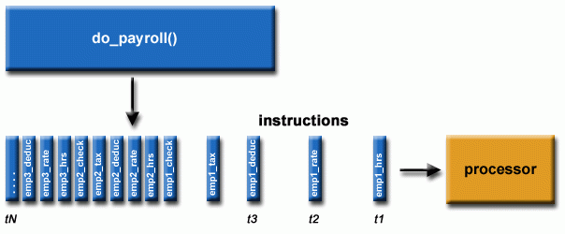

Serial Computing (Courtesy: Lawrence Livermore National Laboratory)

In simple words, in a default for loop, for every simulation of n, only one simulation would run on one processing core of a computer, this is called serial computing. If the 100-simulation analysis is run in an octa-core machine, for every simulation, only one of the eight cores is utilised, whilst the other seven are idle.

However, by using parallel computing, at any given time, in the said 100 simulations, eight at a time can be run from the available eight distinct cores, and if one is finished, another simulation takes its place, thus not getting influenced by the rest seven operation’s progress. Hence, in a shared network computer with hundreds of processing cores, this makes a big difference in run times.

This is achieved because every single simulation of an OxCal calibration and analysis has its own distinct set of procedures, though same for all, and more importantly, each simulation is independent of the other and no conditions of a current run are determined by a previous one.

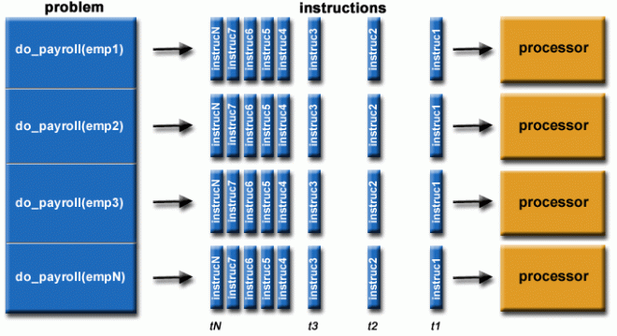

Parallel Computing (Courtesy: Lawrence Livermore National Laboratory)

Parallel computing in OxCal:

A parallel computing approach could be incorporated into a linear radiocarbon age calibration and origination tracking model. However, OxCal was originally designed to be run from its website or locally through a GUI displayed on a browser instead of the method followed here- to employ a custom script, oxcalScriptGen, which reveals that OxCal was never meant or designed to be run with such a parallelisation based simultaneous runs.

Some attempts were made with a parallel computing package, foreach. However, this approach could not achieve parallel computing due to the externally sourced functions from other modules. One of the foremost concerns with foreach was how to have an iteratable element that would felicitate a least-intervenable loop for running in parallel computing. The solution was to have a uniquely identifiable element that gets passed through the loop, like an indice.

Accordingly, the OxCal script files generated by oxcalscriptgen were modified to be named in numerically successive order using a for-loop. Thus, the files had to be saved locally to make them iteratable, unlike formerly, where they were deleted/replaced after every iteration. Hence, the files were designated to be named trap_set_1.oxcal, trap_set_2.oxcal,…trap_set_100.oxcal etc. for trapezoid and unif_set_100.oxcal for uniform, thus enabling to be shuffled (iterated trough) in order within the parallel computing function.

Finally, parLapply was used instead of foreach (Moll-Elsborg, 2020), which has enhanced the basic R functions, apply() and Lapply(). The lapply function applies a specified function to the contents of a list object, here the list of all locally saved scripts. Therefore, the function inputs a list or data frame and outputs the results as a list (Mishra, 2017). parLapply is the parallel computing version of lapply; it is also easy to incorporate a normal lapply function setup to embed it with a cluster framework. Further, parLapply is also comparatively faster than foreach (Oehm, 2018).